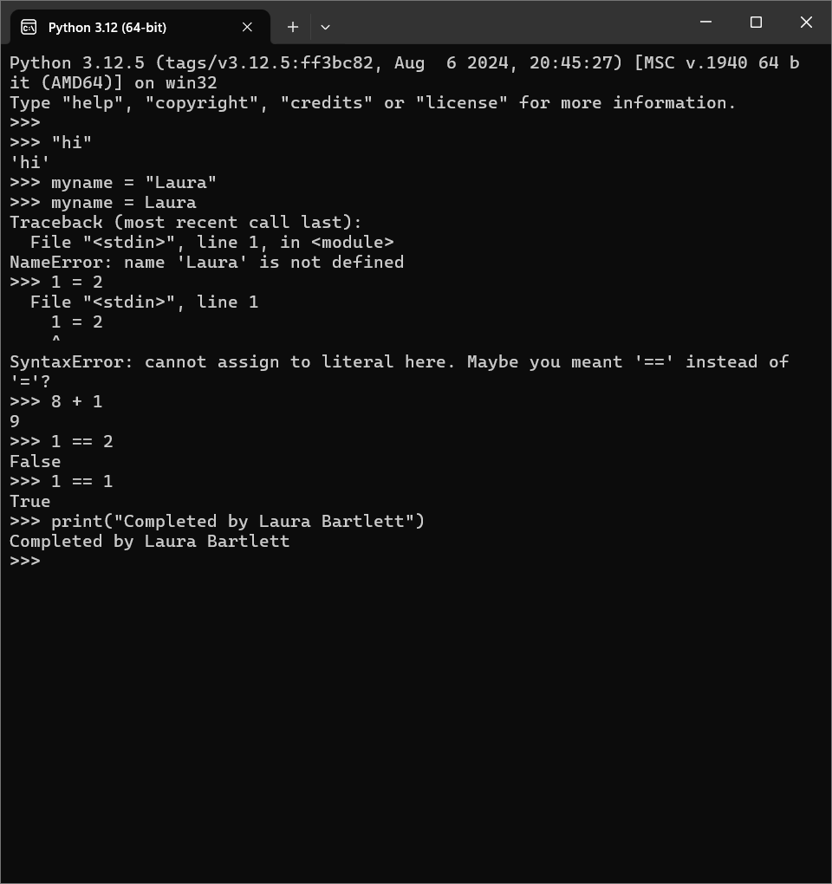Laura Bartlett - Assignment #1